Business Case: **Electric Vehicle Specifications**

#### EV buyers and manufacturers struggle to understand how current electric vehicles differ beyond brand. With hundreds of models on the market, it's hard to compare them based on performance, range, efficiency, or charging speed between Sedan and SUV. The purpose is to discover hidden groups of similar EVs (e.g., budget city EVs, long-range commuters, performance cars) based on technical specs like range, battery size, acceleration, and efficiency among Sedan and SUV.

**Data Understanding**

**## View column names and sample data**

Select * from `electricvehicleproject.EVSet1.EvDataset` LIMIT 10;

**## Check for nulls in key columns**

SELECT COUNT(*) AS total_records,

COUNTIF(range_km IS NULL) AS null_range,

COUNTIF(price_inr IS NULL) AS null_price,

COUNTIF(battery_capacity_kWh IS NULL) AS null_battery

FROM `electricvehicleproject.EVSet1.EvDataset`;

**Business Questions & Queries**

**Q1.** Which brands have the most EV models?

SELECT BRAND, count(*) as model_count FROM `electricvehicleproject.EVSet1.EvDataset`

group by brand

order by model_count desc

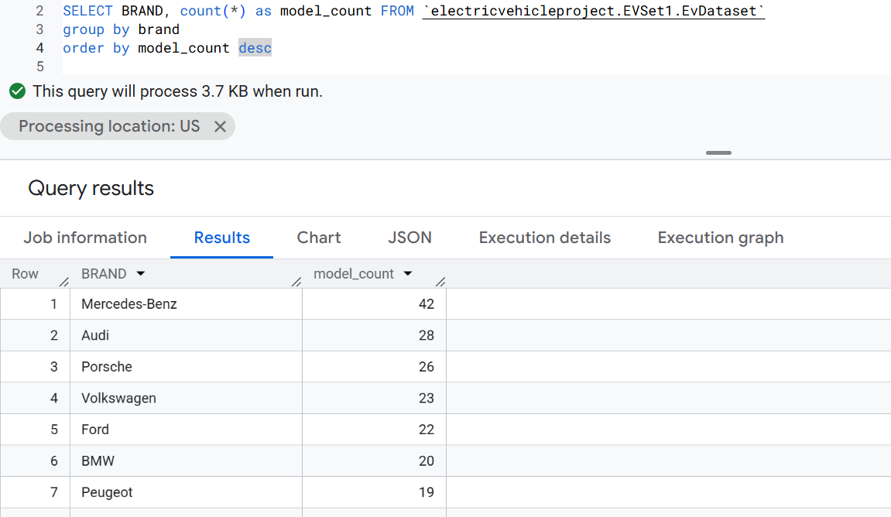

**✅ I Insight:**

**Mercedes-Benz leads the EV market with 42 distinct models**, followed by Audi (28) and Porsche (26). This indicates that premium German brands dominate in terms of variety and product depth, targeting multiple customer segments. Volkswagen and Ford also maintain strong portfolios, reflecting their aggressive EV expansion strategies.

2. **Which brands offer the longest average range?**

SELECT BRAND, round(avg(range_km),2) as avg_range FROM `electricvehicleproject.EVSet1.EvDataset`

where range_km is not null

group by brand

order by avg_range desc

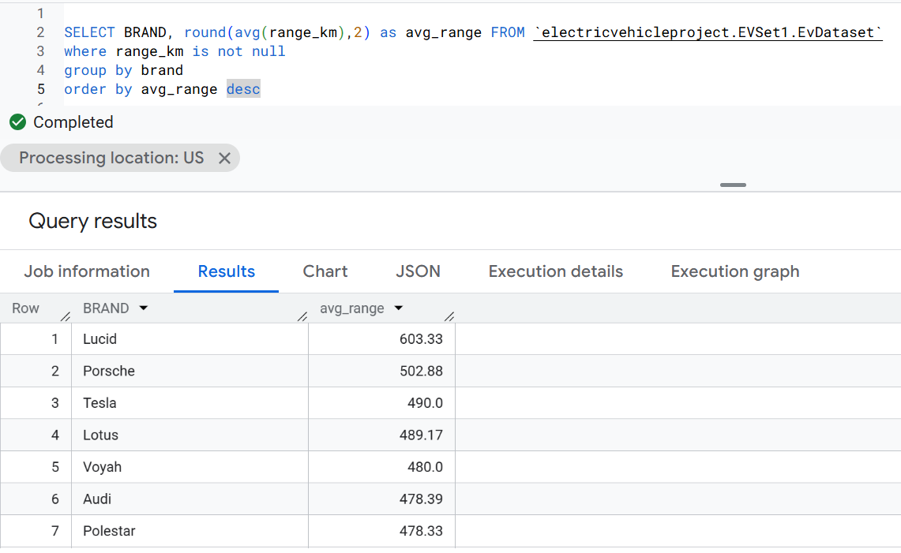

**✅ I Insight:**

**Lucid leads the market in average range** with an impressive 603 km, positioning it as a top choice for long-distance travel. **Porsche and Tesla** follow closely, both offering over 490 km of average range. This highlights their focus on endurance and highway performance, while **Lotus, Audi, and Polestar** round out the top-tier options for range-conscious EV buyers.

**Q3**. **Compare average range, battery, and acceleration by body type (SUV vs Sedan)**

SELECT car_body_type, round(avg(range_km),2) as avg_range,round(avg(battery_capacity_kWh),2) as avg_battery,

round(avg(acceleration_0_100_s),2) as avg_acceleration

FROM `electricvehicleproject.EVSet1.EvDataset`

where car_body_type in ('SUV','Sedan')

group by car_body_type

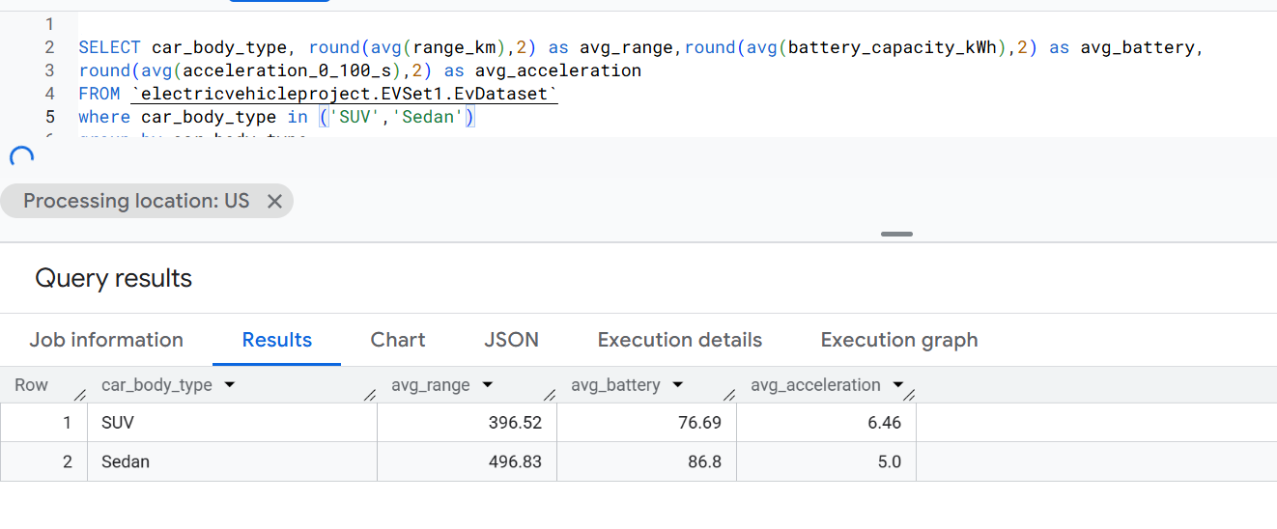

**✅ I Insight:**

**Sedans significantly outperform SUVs** in all key performance areas:

* They offer **100+ km more average range**
* Have **larger battery capacity**
* And accelerate **1.5 seconds faster** on average (5.0s vs 6.5s)

This suggests that **Sedans are better optimized for performance and efficiency**, while **SUVs may prioritize size, space, and utility** over speed and range.

**Q4.** **Which 5 Sedan and SUV models have the best efficiency (lowest Wh/km)?**

SELECT brand,model,car_body_type,efficiency_wh_per_km

FROM `electricvehicleproject.EVSet1.EvDataset`

where car_body_type in ('SUV','Sedan') and efficiency_wh_per_km is not null

order by efficiency_wh_per_km asc

limit 10

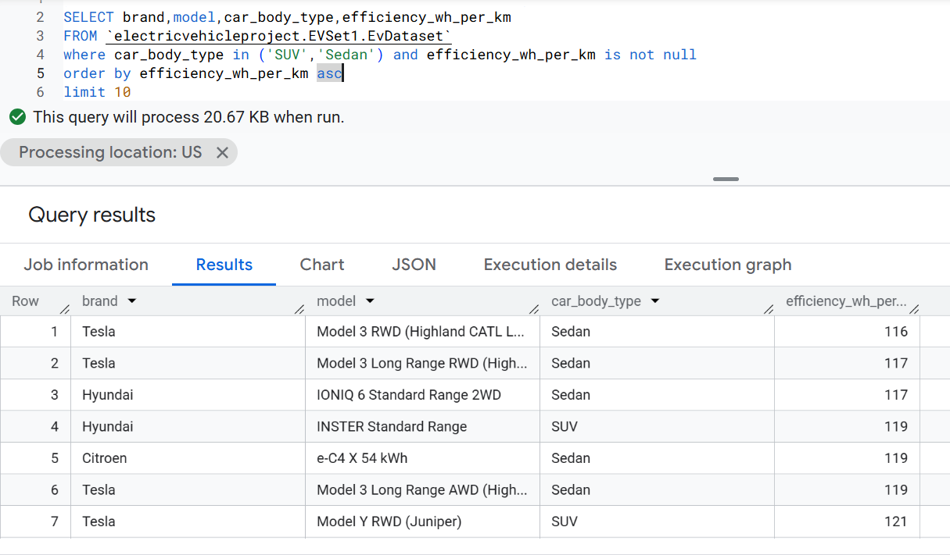

**✅ I Insights:**

* **Most Efficient Model**: Tesla Model 3 RWD (Highland CATL LFP) at **116 Wh/km**
* **Sedans dominate** the top spots for efficiency.
* **Tesla** and **Hyundai** appear frequently in the most efficient list.
* **SUVs** like the Hyundai INSTER and Tesla Model Y appear slightly less efficient but still competitive

**Q5.** **How many EVs support fast charging in SUV vs Sedan category?**

SELECT

  car_body_Type,

  COUNT(*) AS Total_Models,

  COUNTIF(LOWER(Fast_Charge_Port) IS NOT NULL AND LOWER(Fast_Charge_Port) != 'none') AS Fast_Charging_Supported

FROM `electricvehicleproject.EVSet1.EvDataset`

WHERE car_body_Type IN ('SUV', 'Sedan')

GROUP BY car_body_Type;

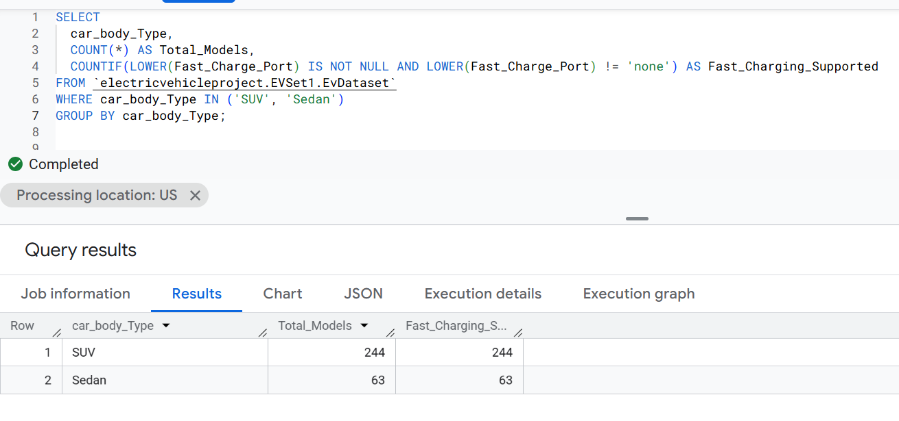

**Q6.** **Segment-wise count of models.**

SELECT car_body_type, segment, count(model) as model_count FROM `electricvehicleproject.EVSet1.EvDataset`

group by car_body_type,segment

order by car_body_type,model_count desc

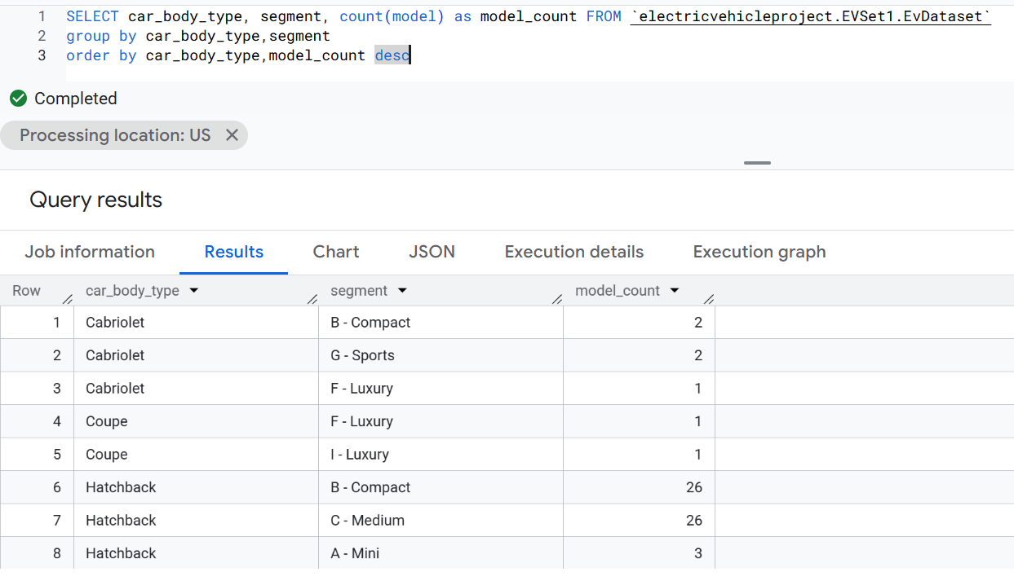

**✅ I Insights:**

1. **Hatchbacks lead** in variety, especially in **Compact (B)** and **Medium (C)** segments (26 models each).
2. **Cabriolets and Coupes** are niche, with only 1–2 models per segment.
3. **Luxury segments** (F & I) mostly appear in Coupes and Cabriolets, indicating premium positioning.
4. EV focus is clearly on **affordable, urban-friendly body types** like Hatchbacks.

**Q7. Which brands offer the fastest accelerating EVs?**

SELECT brand,model,car_body_type,acceleration_0_100_s FROM `electricvehicleproject.EVSet1.EvDataset`

where acceleration_0_100_s is not null

order by acceleration_0_100_s asc

limit 10

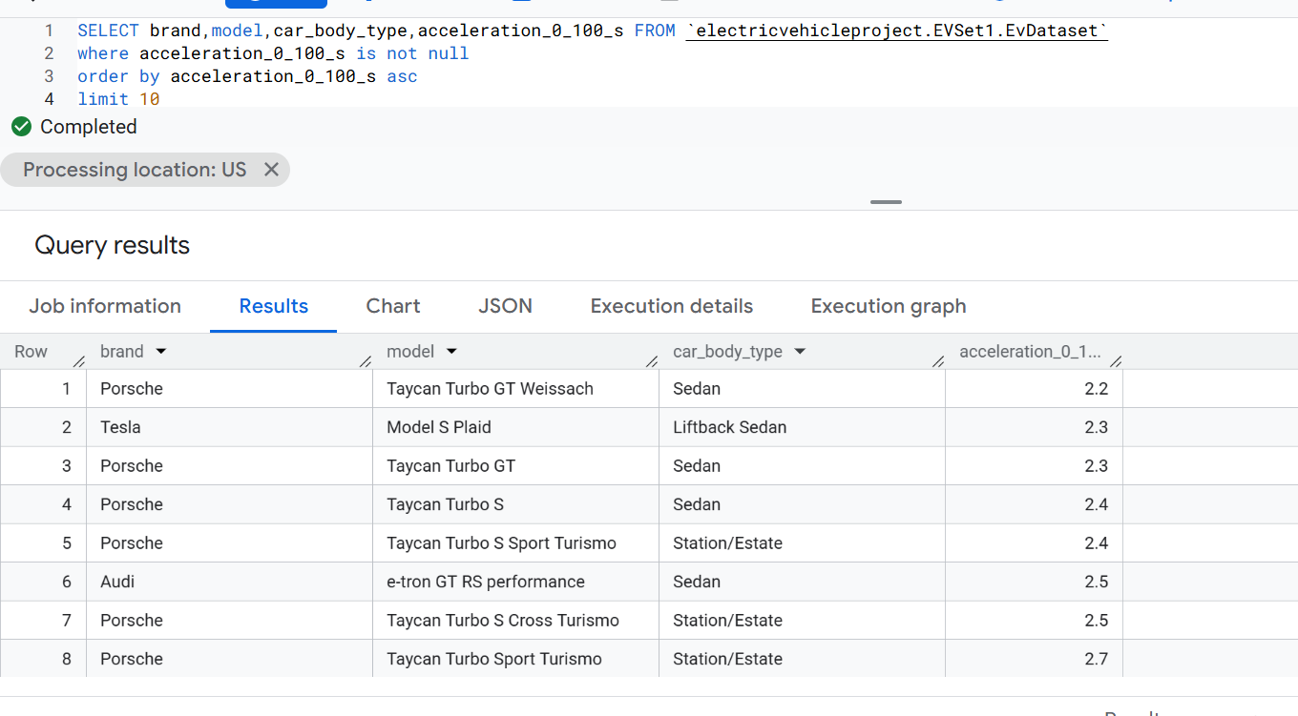

**✅ I Insights:**

• **Fastest EV**: Porsche Taycan Turbo GT Weissach (2.2 sec).

• **Tesla’s quickest**: Model S Plaid (2.3 sec), second only to Porsche.

• **Porsche dominates**: 6 of the top 8 fastest EVs are Porsche Taycan variants.

• **Top body types**: Fastest models are mostly **Sedans** and **Station/Estate**, not sports cars.

• **Audi** enters the top list with e-tron GT RS (2.5 sec), close to Porsche models.

**Q8.** **Compare energy efficiency across segments**

SELECT segment, round(avg(efficiency_wh_per_km),2) as avg_efficiency FROM `electricvehicleproject.EVSet1.EvDataset`

where efficiency_wh_per_km is not null

group by segment

order by avg_efficiency asc

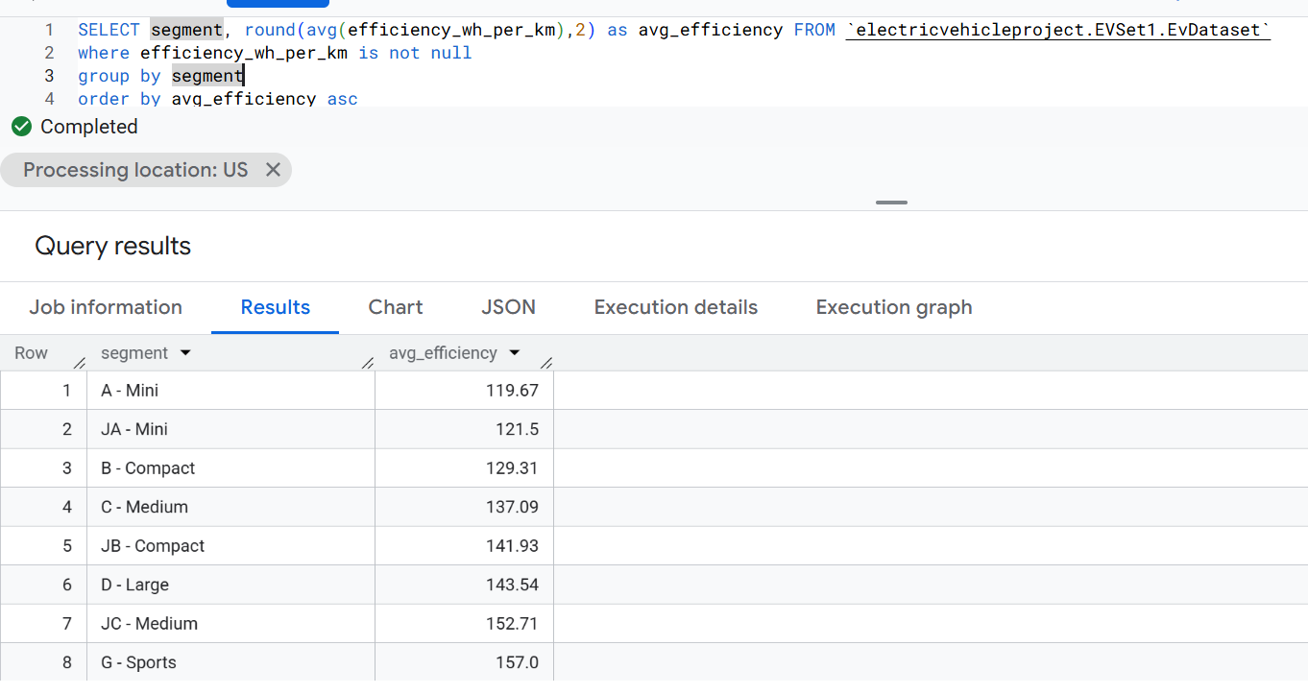

**Q9.** **Battery vs Range Correlation Table**

SELECT brand,segment, range_km, battery_capacity_kWh, round(range_km/battery_capacity_kWh,2) as range_per_kwh FROM `electricvehicleproject.EVSet1.EvDataset`

where range_km is not null and battery_capacity_kWh is not null

order by range_per_kwh desc

limit 10

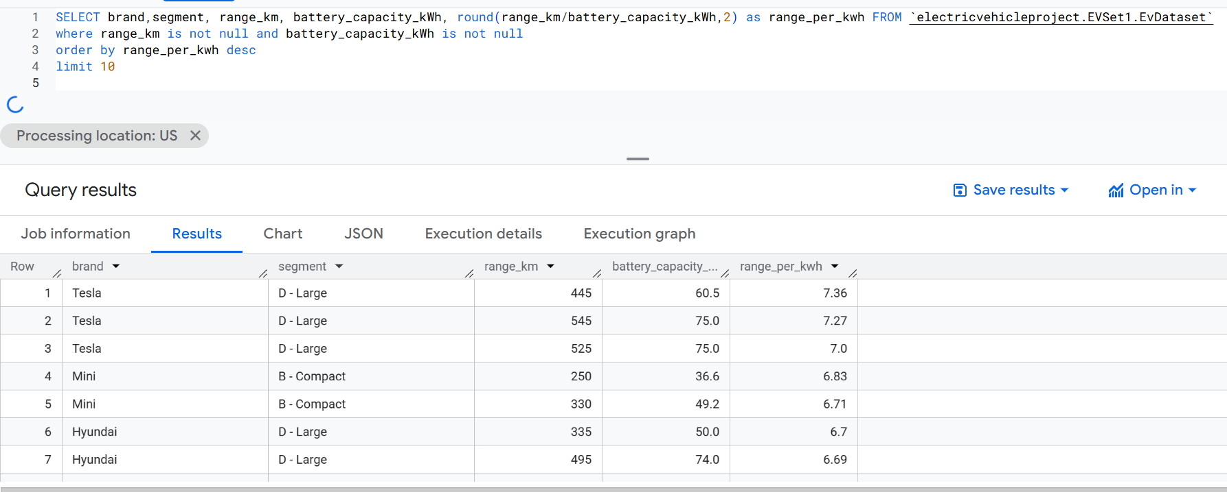

**✅ I Insights:**

• **Most efficient EV**: Tesla (445 km / 60.5 kWh) with **7.36 km per kWh**.

• **Top performers**: All top 3 are **Tesla** models, showing strong energy efficiency.

• **Compact segment**: **Mini EVs** also perform well, with up to **6.83 km per kWh**.

• **Hyundai models** show solid efficiency (6.69–6.7 km per kWh) despite larger battery sizes.

• **Overall trend**: D–Large and B–Compact segments dominate the top efficiency list

**Business Recommendations**

* Focus on Sedans: Better range, battery, and acceleration make them ideal for performance buyers.
* Standardize Fast Charging: All SUVs and Sedans support it—highlight in marketing.
* Expand Compact Hatchbacks: Ideal for urban, budget-conscious consumers.
* Invest in Premium Models: Porsche and Tesla dominate the high-performance market.
* Maximize Efficiency: Follow Tesla’s lead in km per kWh using better design and battery management.
* Limit Niche Body Types: Coupes and Cabriolets have low demand—use them as branding tools.
* Use Segment-Specific Strategy: Customize features by segment (e.g., D–Large for range, B–Compact for efficiency).